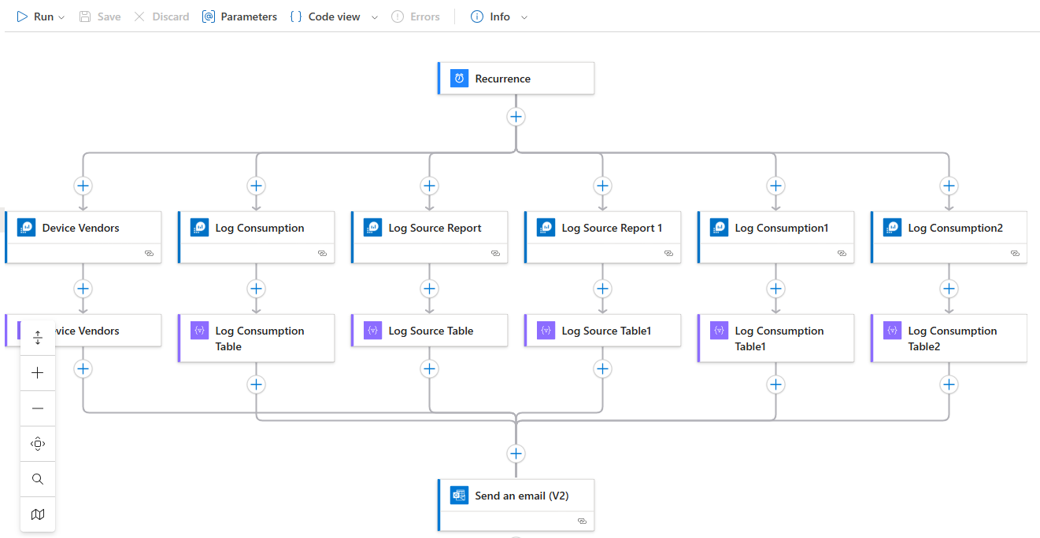

In above we can see log consumption and log source report are multiple times, this is bcz if u have multiple clients and workspaces, in single query it can’t run, so if you have one or 2 clients only one time calling the table is enough.

**Device Vendors:**

Here create CSV table is renamed as Device Vendors., same thing for all.,

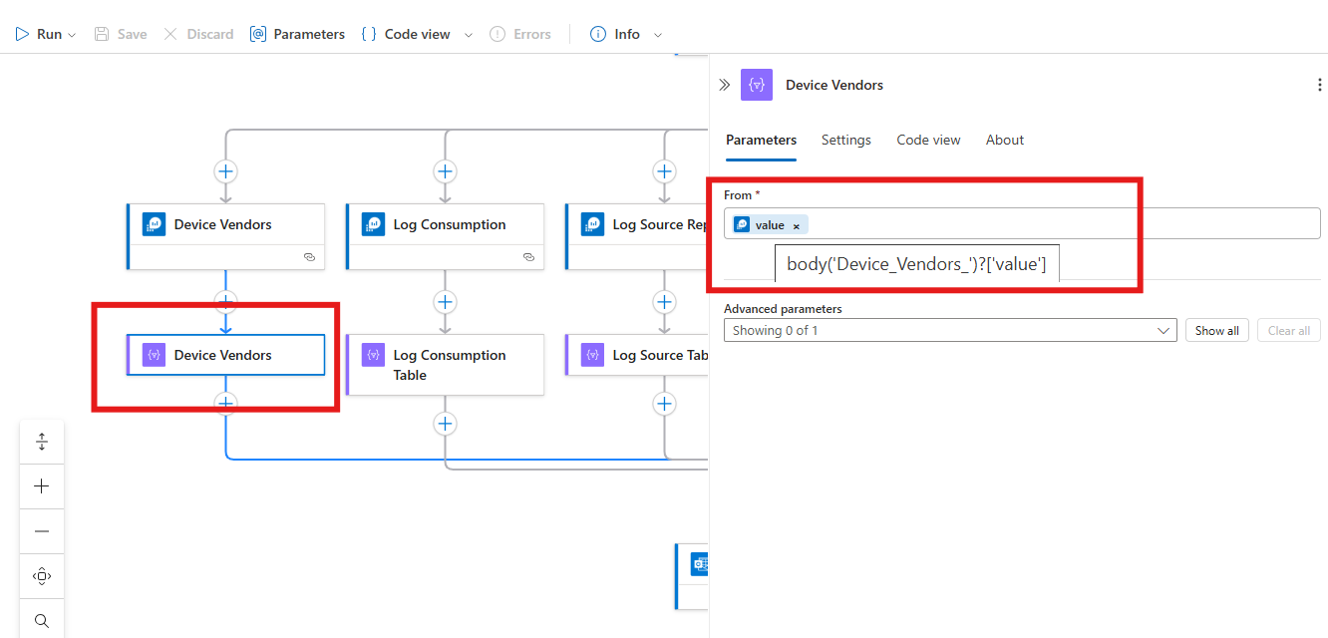

**Log Consumption** -- this will give total log consumption for 1day.

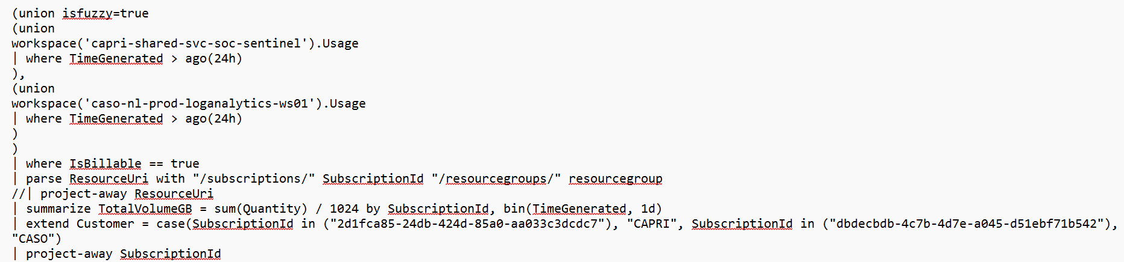

**Log Source Report --** log consumption for each table for 1day.

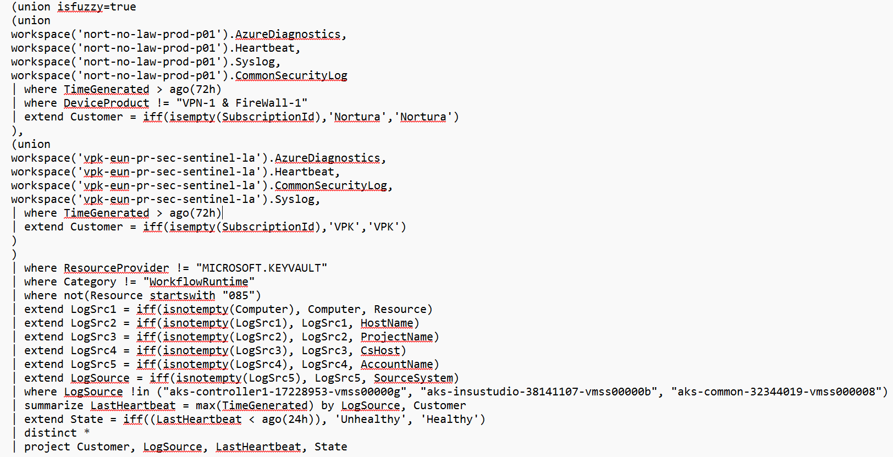

Send an email:

